Ads Creatives: Scope, Sub-Verticals and Policies
Oct 10, 2026 · @sw

What a creative is
A creative is the part of an ad a person sees or hears, plus the page it leads to. Reviewers judge the whole bundle, because a clean headline can hide a violation in the video, the audio or the landing page.
Every creative has four layers:
- Copy: headlines, descriptions, business name, callouts and sitelinks.
- Visual and audio assets: images, logos, video, voiceover, music and on-screen text.
- Destination: the landing page or app the click opens.
- Context: targeting by country, state and age, advertiser verification and certifications, and account history.
Creatives review means deciding whether that bundle follows policy in every place it will run. The customer reports that the risk engine labels over 99% of creatives, so the people see bundles where the layers disagree or several policies overlap.

Sub-verticals within creatives
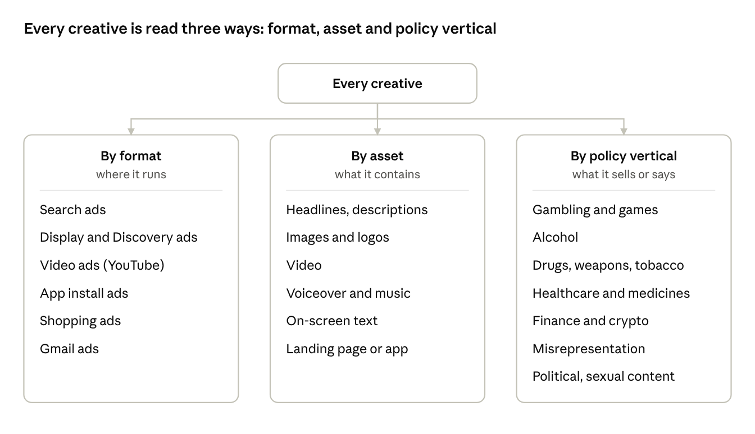
creative sub-verticals · 3 cuts
Reviewers cross all three cuts at once: a gambling ad (policy vertical) in a video (format) whose key claim is spoken, not shown (asset). Policy verticals are where enforcement rules live; format and asset decide where the evidence hides.

Policies reviewers look for
Google's help center lists 30 ad policy areas. They fall into seven groups, and the checks inside each group are similar.
Group | Policy areas | What reviewers check
Restricted goods and services | Alcohol; Gambling and games; Healthcare and medicines; Financial products and services; Cryptocurrencies; Prediction markets; Dating and companionship; Sexual health and wellness; Other restricted businesses | Certification or license held, allowed countries, age targeting, required disclosures
Prohibited products | Dangerous products or services (weapons, explosives, tobacco, recreational drugs); Enabling dishonest behavior | The product or service is not allowed whatever the ad claims
Honesty and deception | Misrepresentation: unacceptable business practices, dishonest pricing, clickbait, misleading ad design, manipulated media, unreliable claims, unclear relevance, unavailable offers | Impersonation, hidden costs, improbable promises, fake buttons, altered media, offers the page cannot deliver
Content standards | Inappropriate content; Sexual content; Political content; Ad protections for children and teens | Imagery and language, who is advertising, and who the ad can be shown to
Rights | Copyrights; Trademarks; Counterfeit goods | Authorization to use names, logos and works; genuine goods
Network abuse and legal | Abusing the ad network; Data collection and use; Legal requirements | Attempts to game review, misuse of user data, local-law compliance
Format and quality | Editorial; Destination requirements; Technical requirements; Ad format requirements; Lead form requirements; Limited ad serving | The page works and matches the ad, text and image quality, format rules
Which policy applies depends on the creative and on where it runs. The same ad can come back allowed, "Eligible (limited)" or "Disapproved" depending on the countries targeted.

How this links to hiring and cases
Creatives review needs skill across all four layers, not mastery of one policy. That is why the hiring profile weights multimodal reading, regional fluency and policy reasoning. Tier 2 cases re-run the same bundle check, then explain to the advertiser what is missing; the workflow write-up covers that flow.

Sources
Policy names and rules come from Google's help pages opened on Oct 10, 2026. The grouping into seven groups and the four creative layers are our framing, not Google's.
- Gambling and games
- Alcohol
- Healthcare and medicines
- Dangerous products or services
- Misrepresentation

